**Secure Socket Layer (SSL)**

When someone connects to a webserver, the webserver authenticates itself which require a process involving exchanging public key, private key and the digital certificate. The digital certificate verifies that the information is sent to the right place. There are two modes of connections in which a browser operates:

1. Normal Connection: This is initiated when we make a connection to a website using http.
2. Secured Connection: This is initiated when we make a connection to a website using https.

“An SSL session always begins with an exchange of messages called the SSL handshake. The handshake allows the server to authenticate itself to the client by using public-key techniques, and then allows the client and the server to cooperate in the creation of symmetric keys used for rapid encryption, decryption, and tamper detection during the session that follows. Optionally, the handshake also allows the client to authenticate itself to the server.”[1]

“In **symmetric-key encryption**, each computer has a secret key (code) that it can use to encrypt the information before it is sent over the network to another computer. Symmetric-key requires that you know which computers will be talking to each other so you can install the key on each one. Symmetric-key encryption is essentially the same as a secret code that each of the two computers must know in order to decode the information. The code provides the key to decoding the message.

Think of it like this: You create a coded message to send to a friend in which each letter is substituted with the letter that is two down from it in the alphabet. So "A" becomes "C," and "B" becomes "D". You have already told a trusted friend that the code is "Shift by 2". Your friend gets the message and decodes it. Anyone else who sees the message will see only nonsense.

The same goes for computers, but, of course, the keys are usually much longer. The first major symmetric algorithm developed for computers in the United States was the Data Encryption Standard (DES), approved for use in the 1970s. The DES uses a 56-bit key.

Because computers have become increasingly faster since the '70s, security experts no longer consider DES secure -- although a 56-bit key offers more than 70 quadrillion possible combinations (70,000,000,000,000,000), an attack of brute force (simply trying every possible combination in order to find the right key) could easily decipher encrypted data in a short while. DES has since been replaced by the Advanced Encryption Standard (AES), which uses 128-, 192- or 256-bit keys. Most people believe that AES will be a sufficient encryption standard for a long time coming: A 128-bit key, for instance, can have more than 300,000,000,000,000,000,000,000,000,000,000,000 key combinations” [2] . An Example of a cipher text is given below:

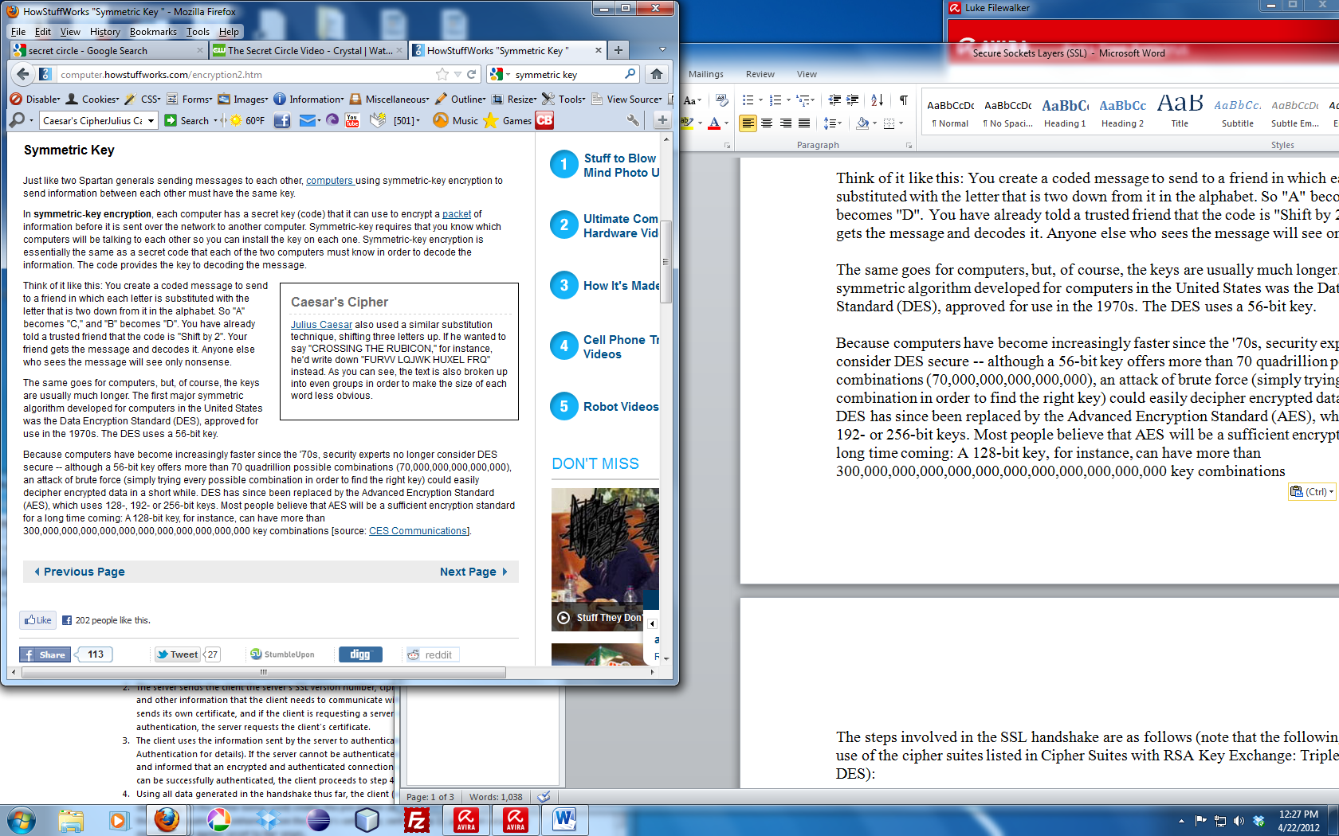

“The steps involved in the SSL handshake are as follows (note that the following steps assume the use of the cipher suites listed in Cipher Suites with RSA Key Exchange: Triple DES, RC4, RC2, DES):

1. The client sends the server the client's SSL version number, cipher settings, session-specific data, and other information that the server needs to communicate with the client using SSL.
2. The server sends the client the server's SSL version number, cipher settings, session-specific data, and other information that the client needs to communicate with the server over SSL. The server also sends its own certificate, and if the client is requesting a server resource that requires client authentication, the server requests the client's certificate.
3. The client uses the information sent by the server to authenticate the server (see Server Authentication for details). If the server cannot be authenticated, the user is warned of the problem and informed that an encrypted and authenticated connection cannot be established. If the server can be successfully authenticated, the client proceeds to step 4.
4. Using all data generated in the handshake thus far, the client (with the cooperation of the server, depending on the cipher being used) creates the pre-master secret for the session, encrypts it with the server's public key (obtained from the server's certificate, sent in step 2), and then sends the encrypted pre-master secret to the server.
5. If the server has requested client authentication (an optional step in the handshake), the client also signs another piece of data that is unique to this handshake and known by both the client and server. In this case, the client sends both the signed data and the client's own certificate to the server along with the encrypted pre-master secret.
6. If the server has requested client authentication, the server attempts to authenticate the client (see Client Authentication for details). If the client cannot be authenticated, the session ends. If the client can be successfully authenticated, the server uses its private key to decrypt the pre-master secret, and then performs a series of steps (which the client also performs, starting from the same pre-master secret) to generate the master secret.
7. Both the client and the server use the master secret to generate the session keys, which are symmetric keys used to encrypt and decrypt information exchanged during the SSL session and to verify its integrity (that is, to detect any changes in the data between the time it was sent and the time it is received over the SSL connection).
8. The client sends a message to the server informing it that future messages from the client will be encrypted with the session key. It then sends a separate (encrypted) message indicating that the client portion of the handshake is finished.
9. The server sends a message to the client informing it that future messages from the server will be encrypted with the session key. It then sends a separate (encrypted) message indicating that the server portion of the handshake is finished.
10. The SSL handshake is now complete and the session begins. The client and the server use the session keys to encrypt and decrypt the data they send to each other and to validate its integrity.
11. This is the normal operation condition of the secure channel. At any time, due to internal or external stimulus (either automation or user intervention), either side may renegotiate the connection, in which case, the process repeats itself.”

**REFERENCES**

1. <http://support.microsoft.com/default.aspx?scid=http://support.microsoft.com:80/support/kb/articles/Q257/5/91.ASP&NoWebContent=1>
2. <http://computer.howstuffworks.com/encryption2.htm>
3. <http://computer.howstuffworks.com/encryption4.htm>
4. http://www.textfixer.com/html/convert-word-to-html.php